## horizontal line



**PAYLATTE**

**Got your backs**

**Mentor: Bhargav.N**

91springboard,

MG Road,

Bangalore.

**Outline**

Payatte (Buy now pay later) allows consumers to make purchases and pay for them at a future date.

Paylatte is a financing avenue that allows shoppers to buy something but pay for it later within a stipulated interest-free period.

Credit cards already give you the option of delaying your payment for a stipulated time. These charge you interest if you do not repay the amount by the due date. But these differ from BNPL in certain aspects. Credit cards typically charge much higher interest rates than the BNPL scheme.

BNPL has certain shortcomings compared to credit cards. The credit limit under BNPL is usually much lower than what is offered by credit cards. While credit cards allow an interest-free period of up to 45 days, some Paylatte option permit a smaller repayment window of 15 to 30 days. Getting approval from the Paylatte is easier .

**Objectives**

**User experience:** Paylatte is a significant step up in terms of user experience. Credit card payments, even when conducted digitally, require the user to fill in credit card details followed by authentication which usually relies on OTP generation. BNPL platforms have a shorter transactional process.

**Easy payments:** The format makes it easy for a buyer to make a purchase even if they don’t have enough funds at the time and make repayments later

**Business Strategy**

Paylatte makes money from both users and vendors.

1. In case of users, Users will pay Paylatte a processing fee ranging from 2% to 8% of monthly credit limit usage.
2. However, There are users who may not be able to repay the amount by the due date, on which a late fee is charged per day. The payment of late fee adds to paylatte’s revenue.

**Credit scor**

| S.NO. | Net worth | Credit score | Credit limit |
| --- | --- | --- | --- |
| 1 | < 2000 | < 600 | Risk score |
| 2 | 2000 -10,000 | 600 - 900 | ₹8000 |
| 3 | 10,000 - 30,000 | 600-900 | ₹10,000 |
| 4 | 30,000 - 50,000 | 600-900 | ₹12,000 |
| 5 | < 50,000 | 600-900 | ₹18,000 |

**Processing Fee**

| S.NO | Credit limit usage | Processing Fee |
| --- | --- | --- |
| 1 | 0-1000 | 2% |
| 2 | 1001-5000 | 4% |
| 3 | 5001-10000 | 6% |
| 4 | 10000+ | 8% |

**Late Fee Payment**

| LATE FEE PAYMENT COLLECTION DETAILS | | | | |
| --- | --- | --- | --- | --- |
| Bill amount | 0-1500 | 1501-4000 | 4001-6000 | 6000 |
| Late Charges | ₹10 per day | ₹15 per day | ₹20 per day | ₹30 per day |

**Stakeholders**

* Users
* Investors
* Hanvesh.P (Backend developer)
* Nikhil .P (Front developer)
* Divya.P (Backend developer)
* Bharath.k (frontend developer)

**Workflow**

* The User will sign-up first.
  + Name
  + Email
  + KYC
    - Aadhaar number
    - PAN number
  + Present address
  + Permanent address
  + Phone number
* Credit bureau receives and sends the credit score to the Paylatte.
* Now depending upon the credit score Paylatte will calculate the credit limit and then send it to the user.
* Now the user is able to see the credit limit by login to the paylatte page.
* Whenever the user wants to buy something from a vendor then they chooses Paylatte option to pay for the item.
* Paylatte wil check if the credit limit is sufficient or not.
* If sufficient then Paylatte will be paying on behalf of the user.
* If not then Paylatte will display that payment is not possible through Paylatte.
* At the end of a month Paylatte will generate the credit bill for the user and send it to them.
* Then the user has to pay the amount to the Paylatte on time.
* If it does not happen the Processing fee and late fee will be added.

**Software requirements**

Angular Js

Laravel

Cockroach DB

Redis

**Modules**

1. **User**
2. **Sign up:** The user enters the required information like, Name, Email, PAN number, Phone number and Password for the Paylatte.
3. **Login:** User will login to check the credit limit given by the paylatte.
4. **Credit Bill:** Users will check and clear their credit bill by the month end sent by admin.

d.  **Repayment:** User will Pay to Paylatte after reaching the deadline. Users will pay Processing Fee and also Late Fee when unable to pay on deadline.

**Late Fee Payment**

**function lateFee($bill,$bd,$rd)**

**{**

**$c = Carbon::parse($bd)->diffInDays(Carbon::parse($rd));**

**if($c >30)**

**{**

**$c = $c -30;**

**if($bill >=0 && $bill <= 1500)**

**{**

**$bill +=($c * 10);**

**return $bill;**

**}**

**if($bill >=1501 && $bill <= 4000)**

**{**

**$bill +=($c * 15);**

**return $bill;**

**}**

**if($bill >=4001 && $bill <= 6000)**

**{**

**$bill +=($c * 20);**

**return $bi**

**if($bill >=4001 && $bill <= 6000)**

**{**

**$bill +=($c * 20);**

**return $bill;**

**}**

**if($bill > 6000 )**

**{**

**$bill +=($c * 30);**

**return $bill;**

**}**

**}**

**return $bill;**

**}**

**Paylatte Home page:**

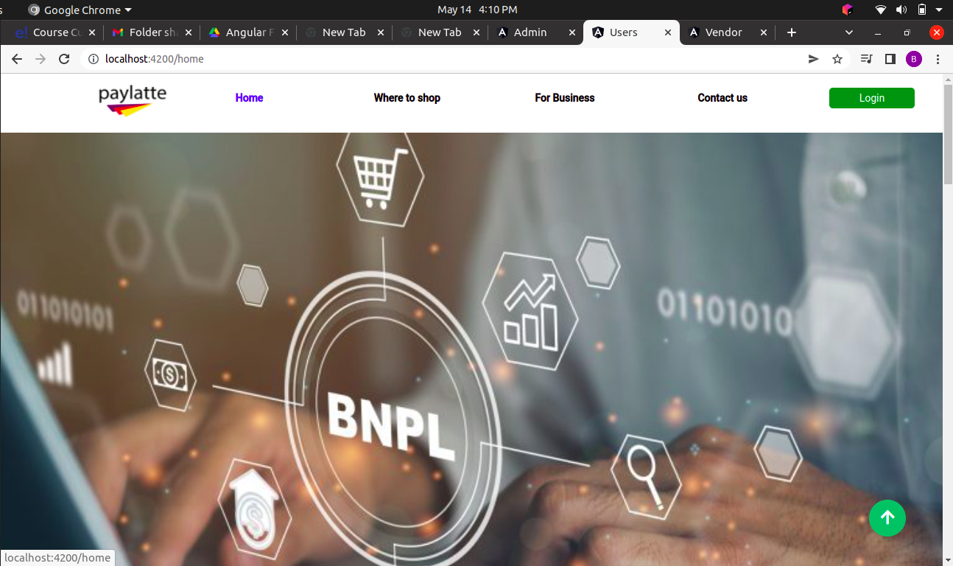

**User Registration page**

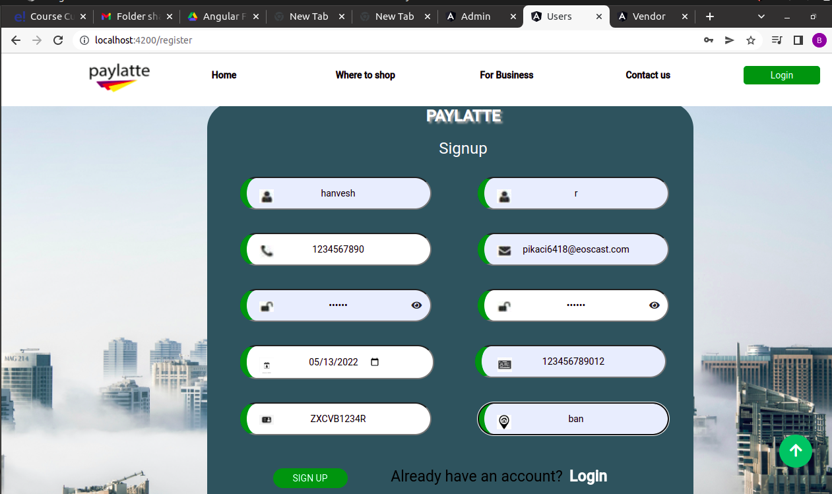

**User Email Verification**

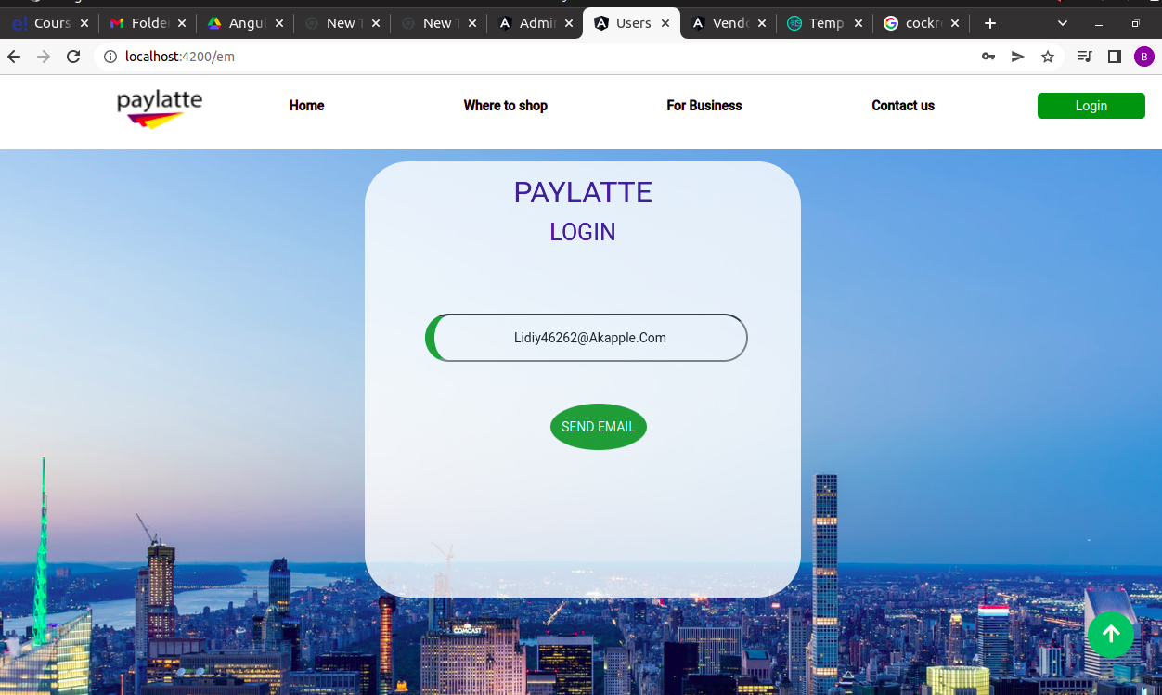

**User Email Verification**

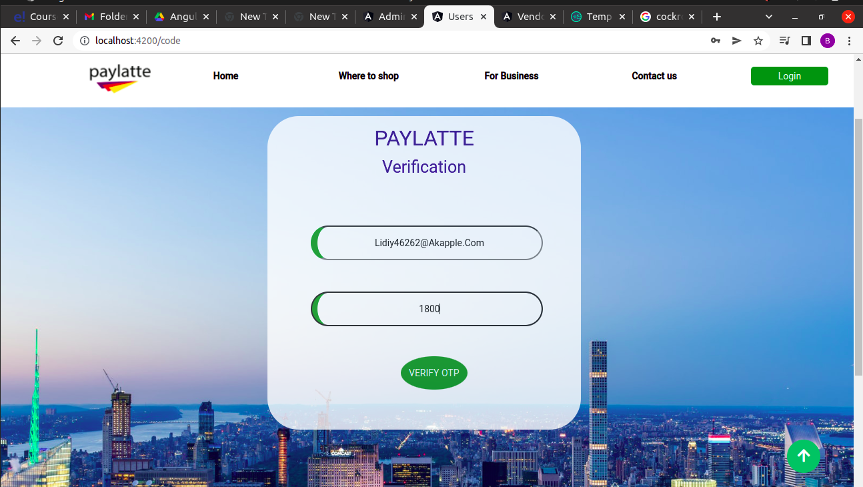

1. **Admin**

a. **Sign up:** Admin will sign up first.

b. **Login:** Admin will login to paylatte to gather the data from the user .

1. *Fetching details from Database:*

Admins will Fetch details like credit score,Net Worth and liabilities

From the credit records sent by the credit bureau.

2. *Setting credit limit:*

Depending on the credit score, Gross revenue and liabilities from the credit records Paylatte will calculate the credit limit of the user. After setting the credit limit they will send the limit to the user.

**Algorithm for calculating the credit limit**

***function* creditLimit($i, $x)**

**{**

***if* ($i >= 600 && $i <= 900) {**

***if* ($x >= 2000 && $x <= 10000) {**

***return* ($i / 900) * 8000;**

**} *elseif* ($x > 10000 && $x <= 30000) {**

***return* ($i / 900) * 10000;**

**} *elseif* ($x > 30000 && $x <= 50000) {**

***return* ($i / 900) * 12000;**

**} *elseif* ($x > 50000) {**

***return* ($i / 900) * 15000;**

**} *else* {**

***echo*("Risk Credit Score");**

**}**

**}**

**}**

where

* $i =is credit score
* $x =Net worth(Gross revenue-liabilities)

All the details like credit score,gross revenue and liabilities will be

Fetch from credit bureau and we are using the ratio of user’s credit-score and largest credit score multiplied by some fixed

amount(fixed by range of their difference between gross revenue

And liabilities) to calculate their credit limit.

c. **payments:** Whenever the user buy a product from vendor then the user will choose this paylatte gateway to pay the vendor.If the credit limit is sufficient to buy the product then the paylatte will able to let the user to buy the product and the paylatte will pay on behalf of the user to vendor.

**Checking Credit balance to pay**

**function diff($a,$b,$c){**

**if (($a ==1) and ($b > $c))**

**{**

**$b = $b - $c;**

**}**

**return $b;**

**}**

d. **Sending Credit Bill:**

The user will receive the credit bill after a month (time period given by paylatte to the user without interest).

**Processing Fee along with Credit Bill**

**function processfee($bill)**

**{**

**if($bill >=1 && $bill <=1000)**

**{**

**$bill +=(0.02 * $bill);**

**return $bill;**

**}**

**if($bill >=1001 && $bill <=5000)**

**{**

**$bill +=(0.04 * $bill);**

**return $bill;**

**}**

**if($bill >=5001 && $bill <=10000)**

**{**

**$bill +=(0.06 * $bill);**

**return $bill;**

**}**

**if($bill >10000)**

**{**

**$bill +=(0.08 * $bill);**

**return $bill;**

**}**

**}**

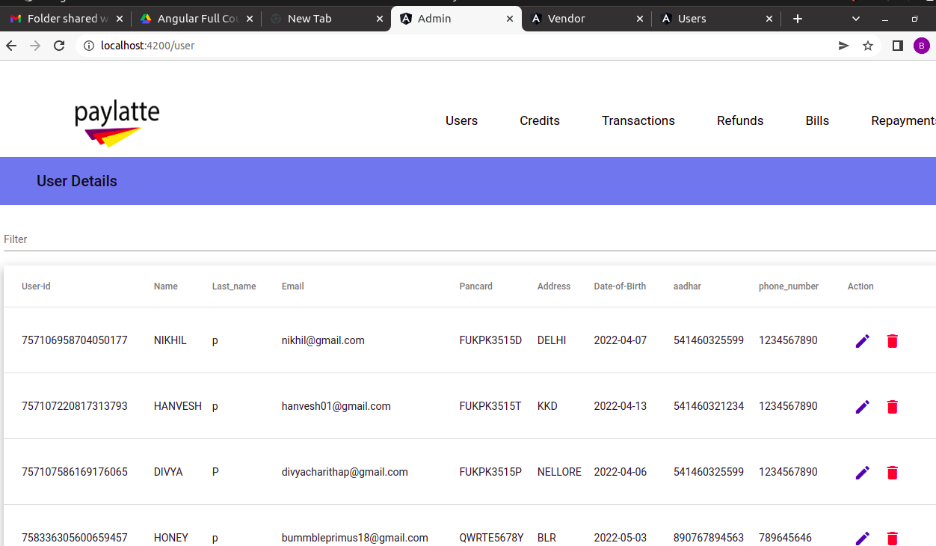

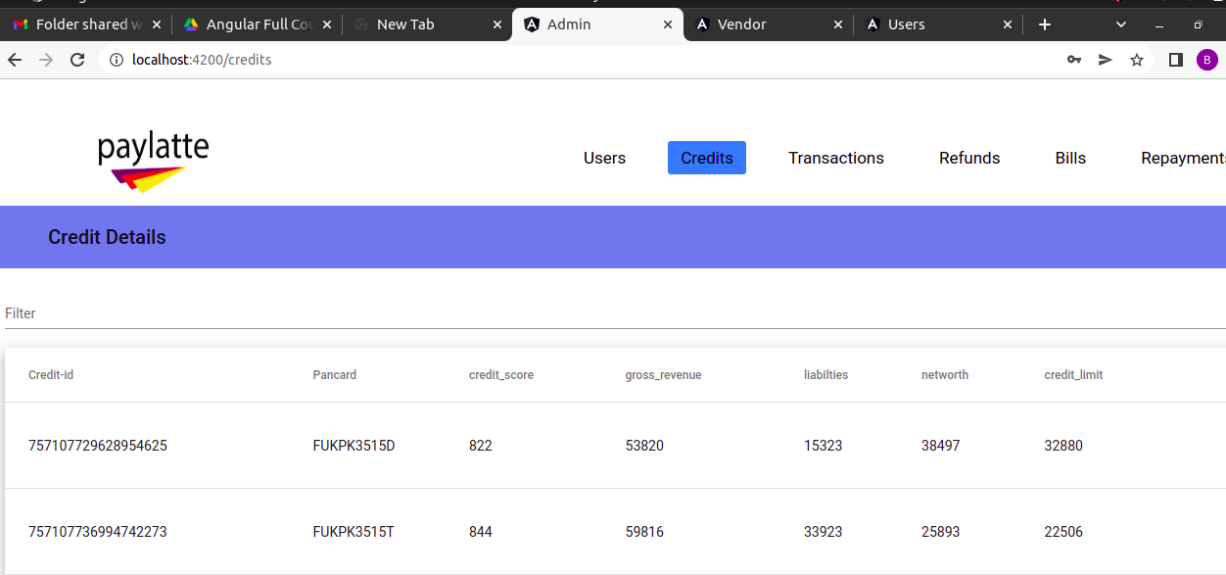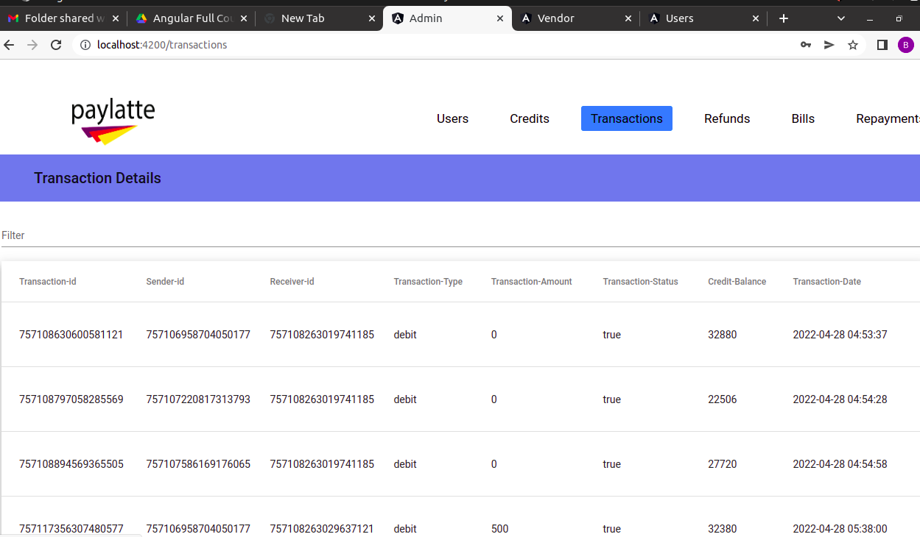

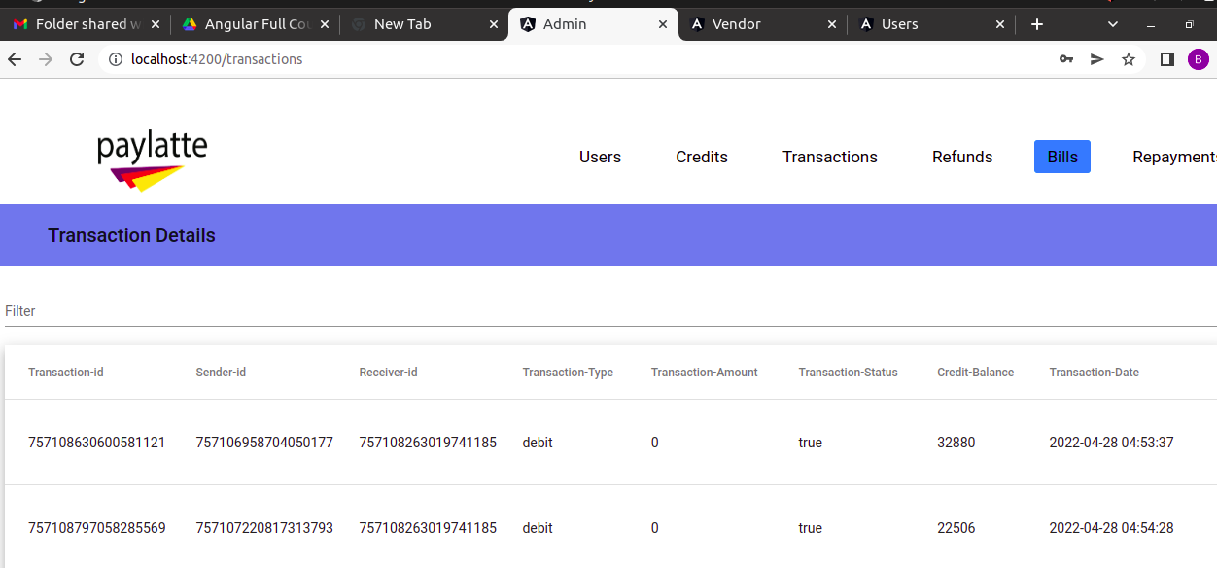

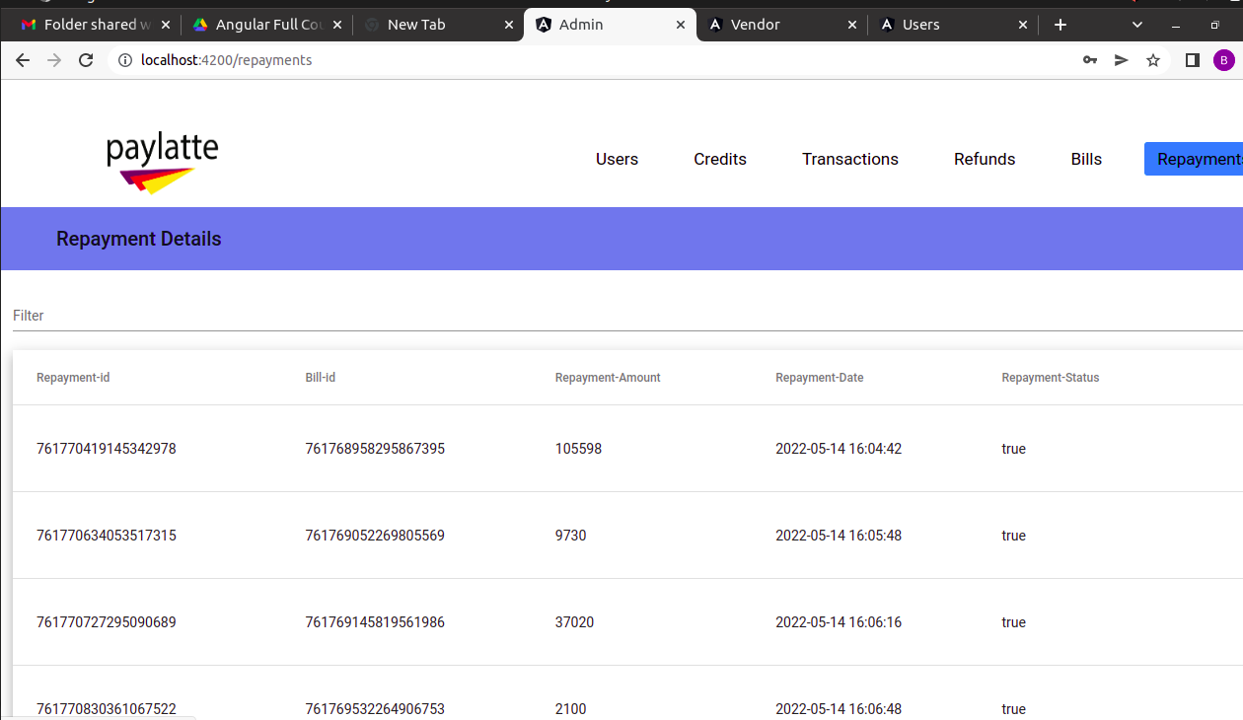

1. **Vendor**

a. **Processing Payments:** If the user chooses Paylatte as a Payment option then paylatte will receive details like cost of items ordered and checks if the credit limit is sufficient or not.

If Sufficient they paylatte will pay on behalf of the user. If not then paylatte will redirect the user to the vendor's payments page.

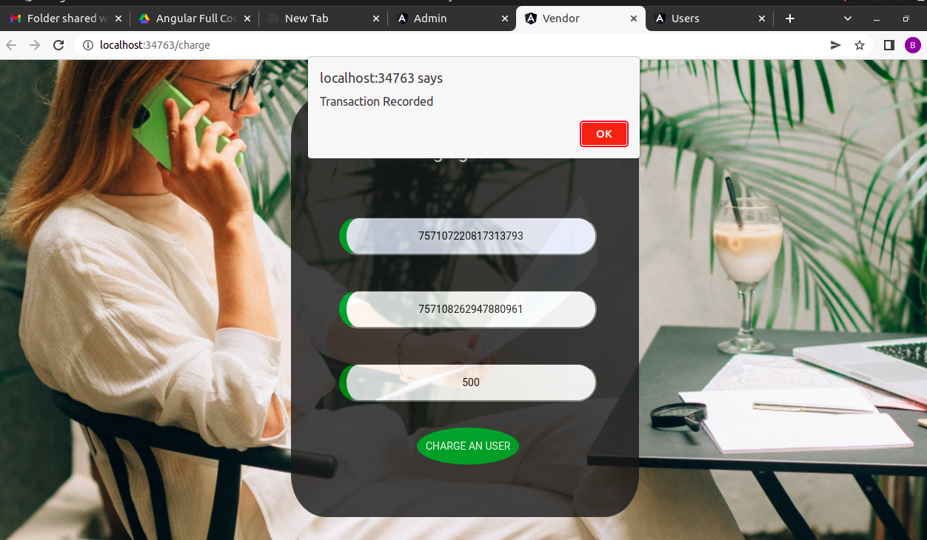

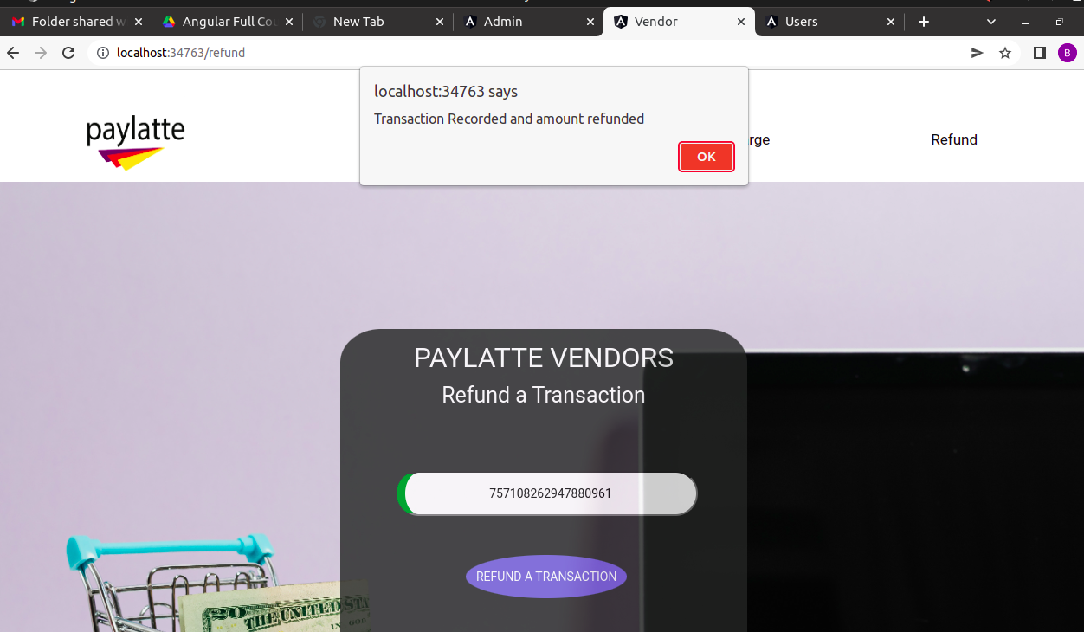

1. **Credit bureau**

a. **Gathering the Details:**

Paylatte will collect details like(PAN number,Phone Number

and Aadhaar number) while the user sign-up and send these

details to the credit bureau to fetch details to from credit

records.

b. **Sending Credit Records:**

After receiving the details from paylatte then credit bureau will send back details from credit records.

**Data flow diagram**

The flow of data of a system to understand the functioning and the limits of a system.

**Level-0:**

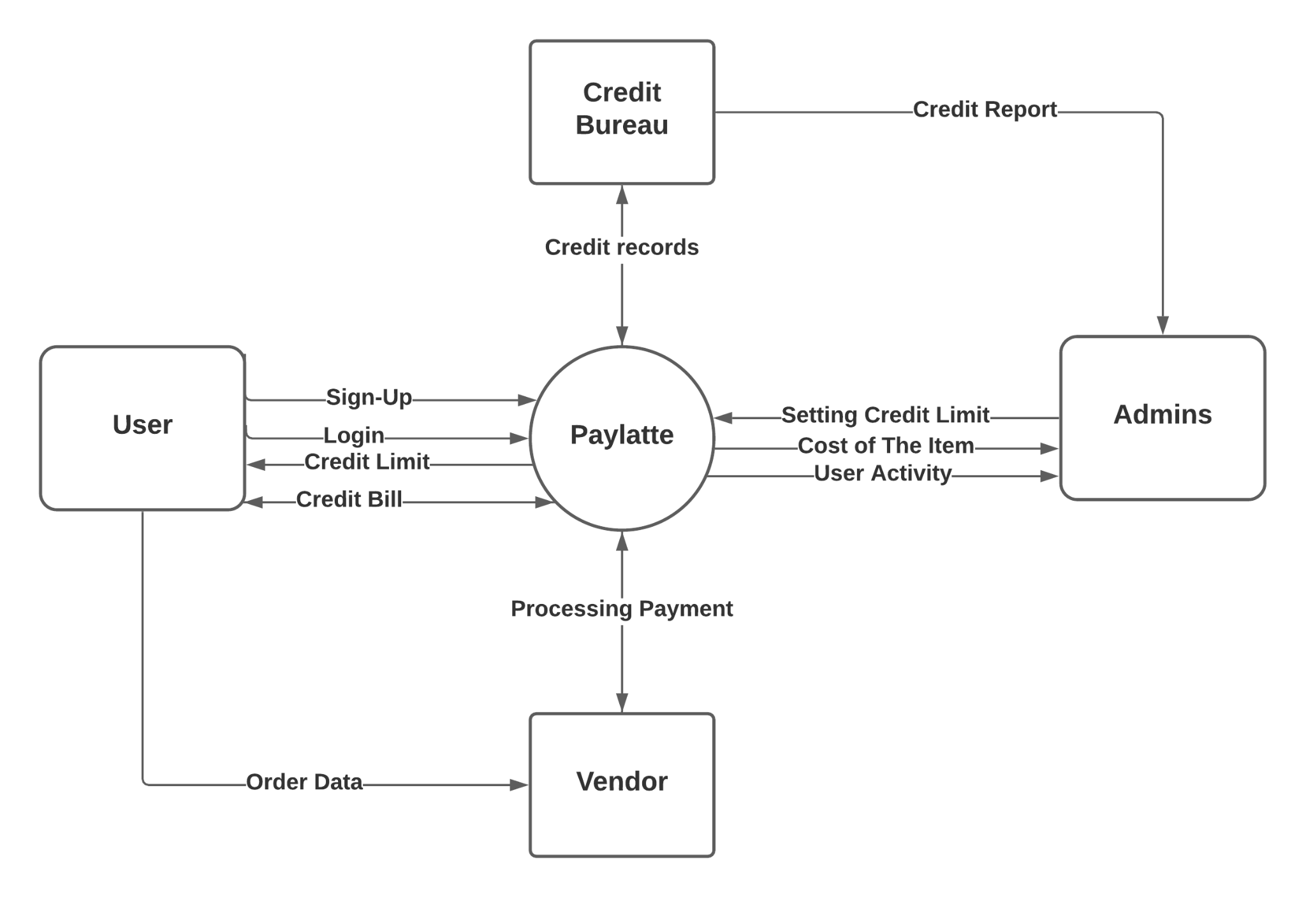

**Level-2:**

**User:**

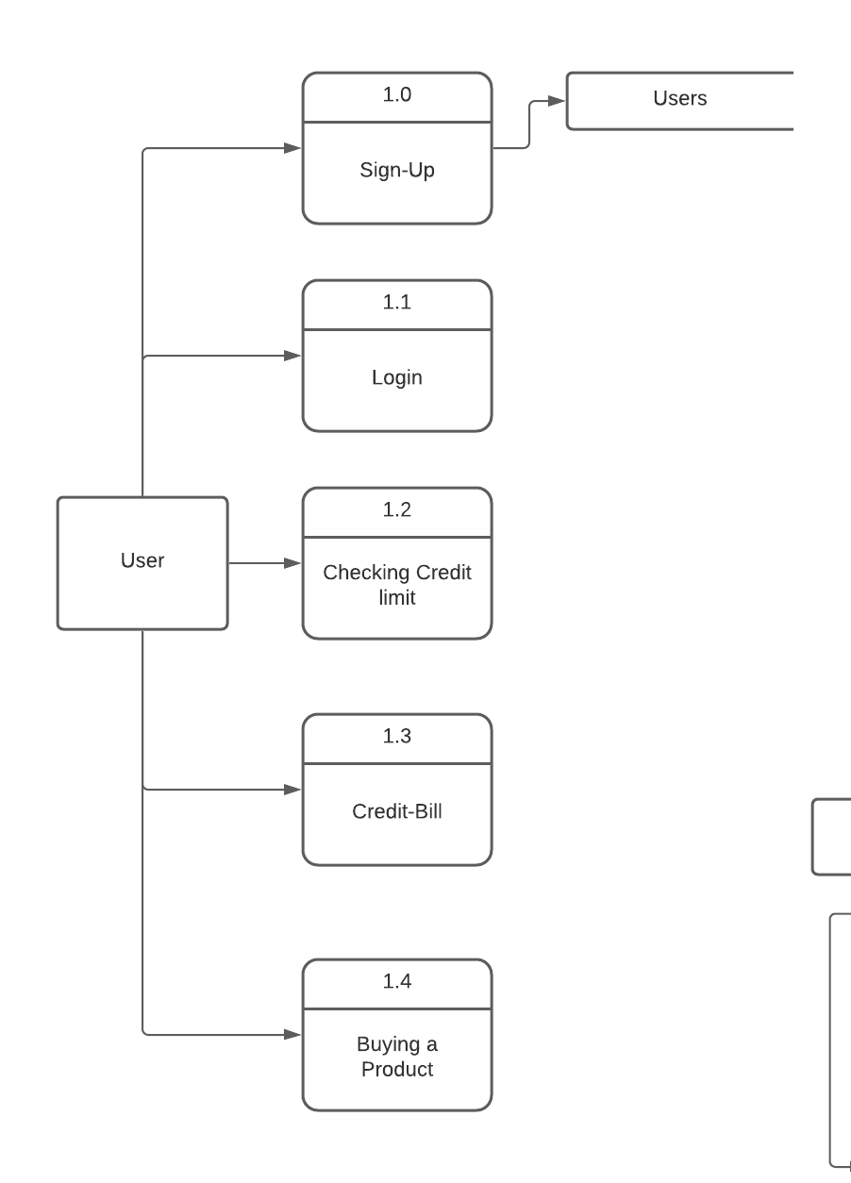

**Credit Bureau:**

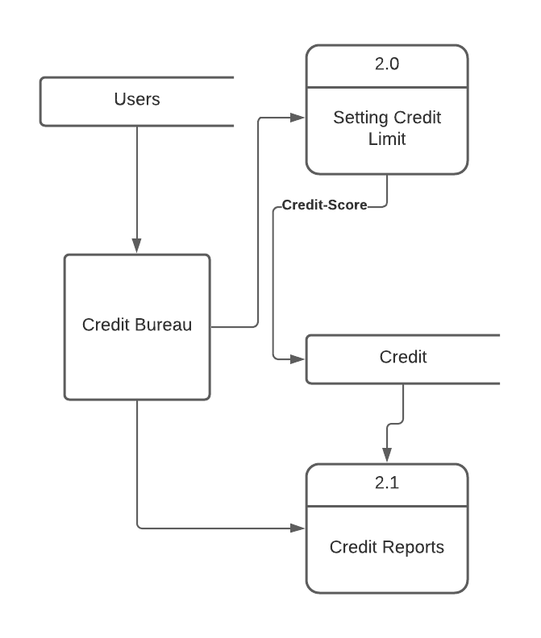

**Vendor:**

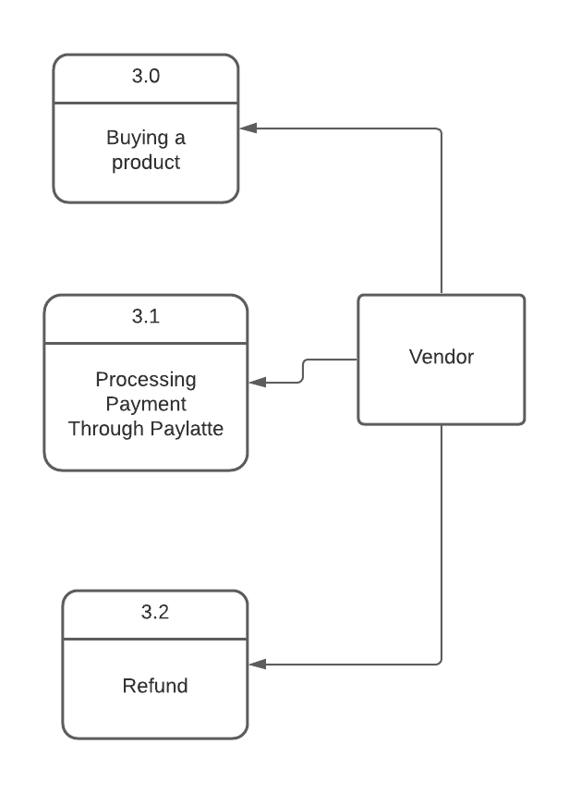

**Admin:**

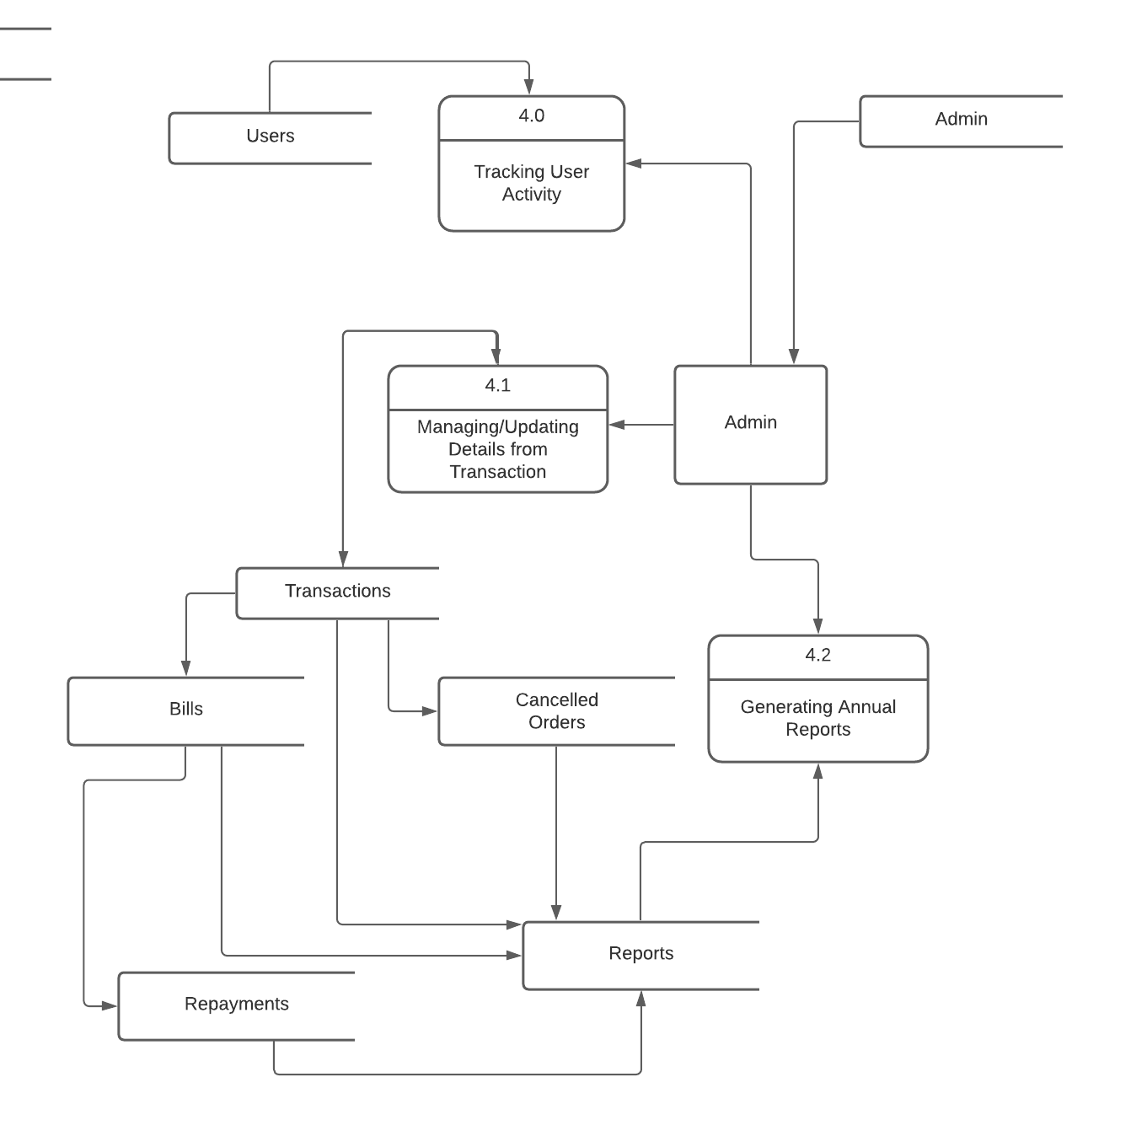

**ER-Diagram for Paylatte**

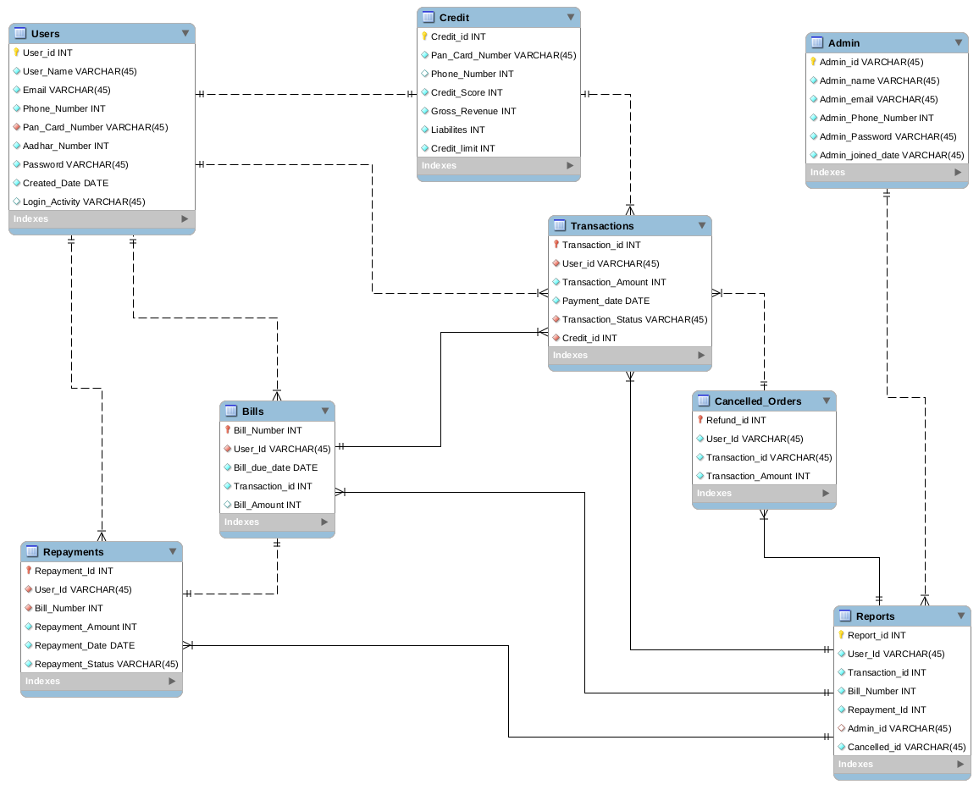

*Sample ER-Diagram for Paylatte*

**Sequence Diagram:**

